
SHED NO 27, SHUBHAM INDUSTRIAL ESTATE, NR. TORENT POWER SUB STATION, KATHWADA GIDC, AHMEDABAD – 382430
GST NO: - 24ARDPD2565K1ZX

info@torqpackagingsolution.com
www.torqpackagingsolution.com

Date: - 10/07/23

To,
Mr. VIKRANT DOBHADA,
RASHIN TAL KARJAT ,
AHMEDNAGAR, MAHARASHTRA-414403

SUB: - SEMI AUTOMATIC FILLING MACHINE

Dear Sir,
Many thanks for your valuable inquiry of above subject. TORQ PACKAGING Solutions Is engage in making preliminary Bottle Filling machines like bottle filling , capping , labeling, etc… in Ahmedabad, We are having dedicated team for manufacturing, customized machine development, Sales, servicing and back office.

Thanks & Regards
Ronak Dave
80000 32128

Semi-Automatic 2 head E-Filling Machine
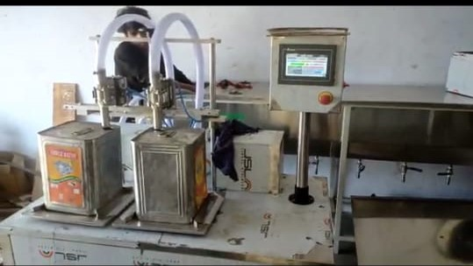
Description
Machine is design for bulk filling and work on load cell technologies. Nozzle on off by accurate pneumatic valve.
Operation
This machine takes material from overhead tank or ground base tank where, material come by pump. Pump speed will be adjusted by VFD(variable frequency drive)
When we place container under nozzle, controller take zero and give signal for filling. After filling exact weight which is adjustable , load cell will give signal to controller so pneumatic will close the valve and stop filling.
Technical Specifications
Valve Diameter |  | 20mm
Number of nozzels |  | 2
Platform Size |  | 700 x 600 mm
Machine Height |  | 3 feet approx
Filling System |  | Load cell Base (Weight base)
Power Consumption |  | 230 V a.c.
Output per hour |  | 600 TO 700 LTR per hour 1 LTR BOTTLE
Salient Features
- ±1 % Filling accuracy on single dose.
- All Contact Parts made of S.S.316
- Rigid vibration free construction for trouble free performance
- A unit to fill variety of liquid and can be used for various types of container
- Total GMP model.
- PLC controller Base system
- 0.5 HP SS 316 gear pump
Utility Requirement
Electrical supply | 1 Phase + Neutral + Earthing
Air Required | 6 kg pressure

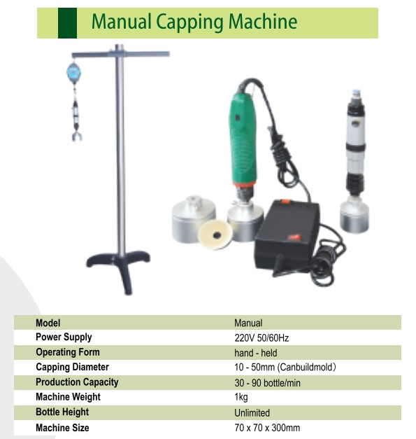

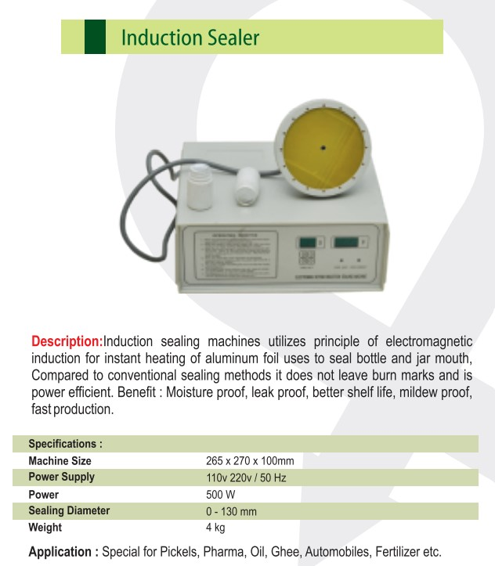

Price Breakup
S.N. | PARTICULERS | CAPACITY | QTY | AMOUNT RS.
1 | SEMI AUTOMATIC 2 HEAD LOADCELL BASE FILLING MACHINE | 500ML TO 5 LTR | 1 | 2,20,000/-
2 | HANDY CAPPING MACHINE | 500 ML TO 5 LTR | 1 | 15,000/-
3 | HANDY INDUCTION CAP SEALING MACHINE | 500 ML TO 5 LTR | 1 | 11,000/-
 | BANK DETAIL:  Account name: - TORQ PACKAGING SOLUTION  Account number: - 8000032128  Bank name: - KOTAK MAHINDRA BANK LTD  Branch: - KATHWADA  IFSC: - KKBK0002606  COMPANY GSTIN : 24AARDPD2565K1ZX | TOTAL |  | 2,46,000/-
 |  | CGST @ 9%
 |  | SGST @ 9%
 |  | IGST @ 18% |  | 44,280/-
TOTAL AMOUNT |  |  |  | 2,90,280/-
TERMS & CONDITIONS |  | For, TORQ Packaging solution
- 60 % Advance on Signing up of Contract
- 40% On Completion of Machinery Manufacturing Before Dispatch / During Inspection of machinery
- Order Once Placed Cannot be Cancelled
- No Refund will be entertained

- TERMS & CONDITION

Commercial terms:
  - The above price does not include the cost of Packing and forwarding, Erection and Commissioning and training of your Operation & Maintenance staff.
  - Insurance extra where ever applicable
  - GST as applicable
  - Subjected to Ahmadabad Jurisdiction Only

Installation & Commissioning
  - At An Extra Cost (To & Fro Loading And Boarding Charge Will Be Extra)

After Sales Services
  - Three Service Free (To & Fro Loading And Boarding Charge Will Be Extra )

  - After Free Service Including Installation 2500/- Rs Charge

Validity
- This Quote is valid for a period of 30 Days.

WARRANTEE
- Warrantee is only applicable against any manufacturing defect.
- The warrantee is only valid for 6 months from the date of supply.
- Client must use the machine/plant/system supplied by us as per the design criteria.
- It shall stand void if the machine is not maintained as instructed.
- Client shall maintain daily operational data sheet
- The use of system beyond the capacity considered during design may affect the performance of the machine and this degradation does not give rise of any obligations on the part of the maker.

